#random 100 row from given data.

df <- APPENC07[sample(nrow(APPENC07), 100), ]

#sort data in ascending order

sortdataFrame <- df[order(df$V3), ]

# assigning secound column sales price (Y)

Ygiven <- sortdataFrame$V2

# assigning 3rd column finished square feet (X)

Xgiven <- sortdataFrame$V3

# L is sum((Xgiven-mean(Xgiven))^2)

L <- sum((Xgiven - mean(Xgiven)) ^ 2)

#the point of estimate b1 for B1

b1 <- sum((Xgiven - mean(Xgiven)) * (Ygiven - mean(Ygiven))) / L

c(b1)= 147.5711

#the point of estimate bo for BO

bo <- mean(Ygiven) - b1 * mean(Xgiven)

c(bo)= -58545.81

#estimated Yhat of response variable y

yhat <- bo + b1 * Xgiven

plot(Xgiven, Ygiven)

lines(Xgiven, yhat, col = "red", lwd = "2")

abline(h = 0, v = 0)

#Dof n-2

n <- 100

# t value as (1-alpha/2 = 0.975) and (n-2 = 98)DOF

t <- qt(0.95, n - 2)

c(t)= 1.660551

#MSE

MSE <- sum((Ygiven - yhat)^2) / n - 2

c(MSE) = 4580674619

#Standard error (Se) of yhat for confident interval

for (i in 1:length(Xgiven)) {

#Some part of Se, G=(xh-xbar)^2/sum((Xgiven-xbar)^2)

G[i] <- ((Xgiven[i] - mean(Xgiven)) ^ 2) / L

# Se of mean response yh

Se[i] <- sqrt(MSE * (1 / n + G[i]))

sePI[i] <- sqrt(MSE * (1 + 1 / n + G[i]))

#yhat H (yh) for every value of Xh (Xgiven[i])

yh[i] <- bo + b1 * Xgiven[i]

#confident Interval of mean response.

CIpos <- yh + t * Se

CIneg <- yh - t * Se

PIpos <- yh + t * sePI

PIneg <- yh - t * sePI

}

lines(Xgiven, CIpos, col = 'blue')

lines(Xgiven, CIneg, col = 'blue')

lines(Xgiven, PIpos, col = 'green')

lines(Xgiven, PIneg, col = 'green')

#text(locator(),labels = c("blue lines is CI", "green lines is PI"))

text(x=Xgiven[80], y=Ygiven[90],label="3->SLR, (2,4)-> CI, (1,5)-> PI") 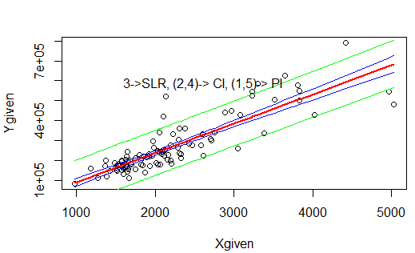

#part-2

#CI and PI at X=xbar mean

mean(Ygiven)=265772.7

CImeanpos<-mean(Ygiven)+t*sqrt(MSE * (1 / n ))

c(CImeanpos)= 277011.4

CImeanneg<-mean(Ygiven)-t*sqrt(MSE * (1 / n ))

c(CImeanneg)= 254534

PImeanpos<-mean(Ygiven)+t*sqrt(MSE * (1+1 / n ))

c(PImeanneg)= 378720.5

PImeanneg<-mean(Ygiven)-t*sqrt(MSE * (1+1 / n ))

c(PImeanneg)= 152824.9